OIT to Create a Virtual Digital Forensics Lab
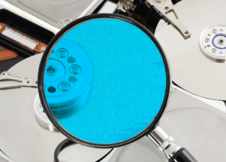
The Office of Information Technology received funding from the CyberWATCH consortium to establish a regional Digital Forensics Lab (DFL) through a grant from the National Science Foundation. The DFL will be a “virtual lab” that will serve as a resource in the teaching of digital forensics at CyberWATCH universities as well as serve as a resource for performing digital forensic investigations in the future. Also, it will offer sample curricula and curriculum materials, including forensic case studies, for use by CyberWATCH member institutions throughout the Washington, D.C. metropolitan area in developing their own forensics courses.
A substantial part of the project involves making available computing power and software appropriate for the forensic examination of both network activity and digital media. The virtual lab will consist of virtual machines running on hardware hosted at the University of Maryland, College Park that will function as forensic workstations. These machines will be used by the member institutions to offer courses in forensic examination of digital media and network activity.
“The University of Maryland has been a part of the CyberWATCH consortium for many years, and we are excited to host this shared Digital Forensics Lab that will be used to provide hands-on experience and education to the next generation of information security professionals in the region,” said Dr. Jeffrey Huskamp, Vice President and Chief Information Officer, University of Maryland.
Funded by the National Science Foundation, the CyberWATCH consortium is composed of higher education institutions, businesses, and government agencies from across the region focused on improving cybersecurity and safety through education.
OIT expects to officially launch the DFL at the 2008 C3 (Cyberethics, Cybersafety, and Cybersecurity) Conference in October during National Cybersecurity Awareness Month. The first full semester the DFL will be available for use in courses will be spring 2009.

